Database Tuning
CS5226
Lab 3

A0079953L – LEE ZHONG DE ROLLEI

TABLE OF CONTENT
Question 1 3
Question 2 5

Question 1
Question 1 is about DML locks. DML locks are required to ensure data integrity during concurrency update triggered by different users. DML locks can be categorized into “table lock” and “row lock”. Basically “table lock” locks the entire data in the table while “row lock” only locks data in the selected row. There are also “DDL locks” that protect the structure of the schema objects and “System Locks” that protect database structures such as data files. Latches, mutexes, and internal locks are entirely automatic. i.e hardly definable by user.

From the example in question 1, we observe the following:

- There are 2 tables employee and department

- “Employee” table has a foreign key “dept_id” referencing “Department table”, however the foreign key is not indexed.

- When we execute @q1emp to delete a tuple with emp_id=2 (without commit), oracle will lock the entire department table, as such when @q1dept is executed to delete dept_id=10, a contention will occur.

- Though the uncommitted deletion of employee tuple with dept_id=10 in @q1emp is not related at all to the department record that @q1dept is deleting, blockage/contention will still occur due to the table been locked entirely by oracle.

- To resolve the issue we could simply create an index for dept_id foreign key in Employee table.

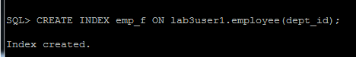

- Now, when we try to repeat step 3 & 5 both deletion will execute without any blocking

Oracle Database maximizes the concurrency control of parent keys in relation to dependent foreign keys. Locking behavior depends on whether foreign key columns are indexed. If foreign keys are not indexed, then the child table will probably be locked more frequently, deadlocks will occur, and concurrency will be decreased. For this reason foreign keys should almost always be indexed.
To check which session is causing the block and which is been blocked we could simply query the system view v$lock.

EXAMPLE:

SELECT x.Type,x.ID1,x.ID2,area1.sql_text as dml_causing_block, area2.sql_text dml_been_blocked
FROM
(
SELECT * from v$lock where type='TM' – TM refers to table lock
AND BLOCK=1
) x

LEFT JOIN v$session blocking_session
ON x.ID1 = blocking_session.SID

LEFT JOIN v$session been_blocked_session
ON x.ID2 = been_blocked_session.SID

LEFT JOIN v$sqlarea area1
ON blocking_session.sql_address = area1.address
AND blocking_session.sql_hash_value = area1.hash_value

LEFT JOIN v$sqlarea area2
ON blocking_session.sql_address = area2.address
AND blocking_session.sql_hash_value = area2.hash_value

Question 2
Part 1: Screenshot of Transaction A
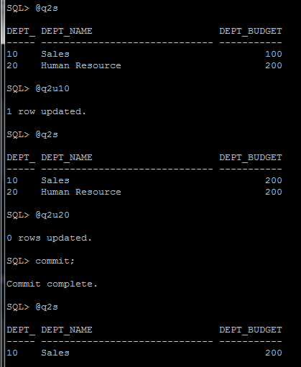

Part 1: Screenshot of Transaction B
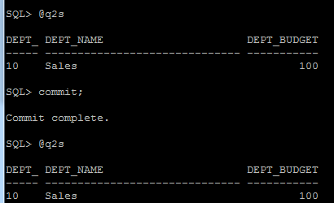
Yes. It is equivalent to that produced by some serial execution (B, A)
Part 2: Transaction A
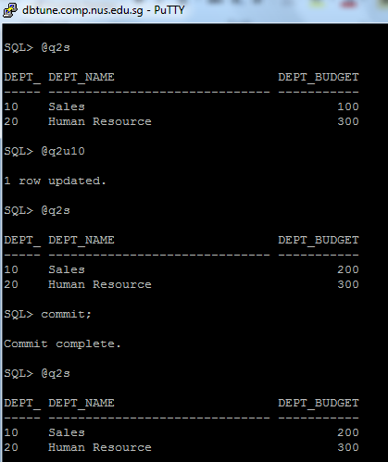

Part 2:Transaction B
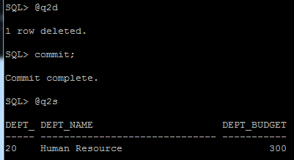

Yes. It is equivalent to that produced by some serial execution (A, B)

